# EXPERIMENT NO. 1

## AIM

To study various DDL commands - CREATE

# Question

Create the following Tables

## Table 1: DEPOSIT

ACTNO VARCHAR2(5) PRIMARY KEY, FIRST LETTER MUST START WITH ‘D’ CNAME VARCHAR2(15) FOREIGN KEY REFERENCES CUSTOMER

BNAME VARCHAR2(20) FOREIGN KEY REFERENCES BRANCH AMOUNT NUMBER (8,2) NOT NULL, CANNOT BE 0

ADATE DATE

create table deposit(acno varchar(5) check(acno like 'd%')primary key,cname varchar(15)references customer(cname),bname varchar(20)references branch(bname),amount float(8) check(amount>0)not null,adate date)

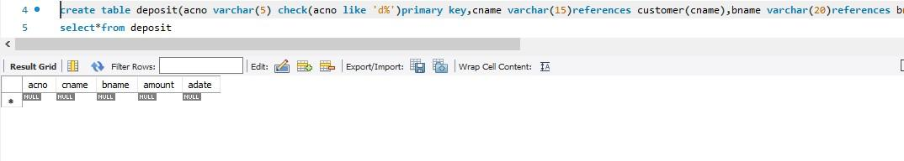

## Table 2: BRANCH

BNAME VARCHAR2(20) PRIMARY KEY

CITY VARCHAR2(30) NOT NULL , any one of NAGPUR, DELHI, BANGALORE, BOMBAY

create table branch(bname varchar(20) primary key,city varchar(30) check(city in('nagpur','delhi','banglore','bombay'))not null);

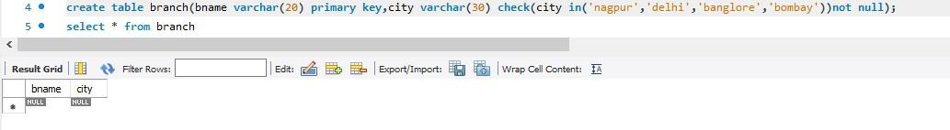

## Table 3: CUSTOMER

CNAME VARCHAR2(15) PRIMARY KEY CITY VARCHAR2(20) NOT NULL

create table customer(cname varchar(15) primary key,city varchar(20) not null)

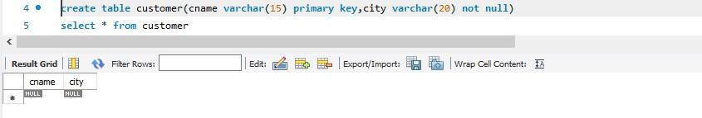

## Table 4: BORROW

LOANNO VARCHAR2(8) PRIMARY KEY / FIRST LETTER MUST START WITH ‘L’ CNAME VARCHAR2(15) FOREIGN KEY REFERENCES CUSTOMER

BNAME VARCHAR2(20) FOREIGN KEY REFERENCES BRANCH AMOUNT NUMBER(8,2) NOT NULL, CANNOT BE 0

create table borrow(loanno varchar(8) check(loanno like 'l%')primary key,cname varchar(15)references customer(cname),bname varchar(20)references branch(bname),amount float(8)check(amount>0)not null)

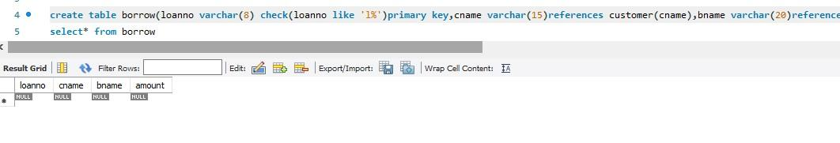

**INSERTION OF VALUES**

1. **Inserting values to Branch**

| VRCE | NAGPUR |
| --- | --- |
| AJNI | NAGPUR |
| KAROLBAGH | DELHI |
| CHANDNI | DELHI |
| DHARAMPETH | NAGPUR |
| MG ROAD | BANGALORE |



| ANDHERI | BOMBAY |
| --- | --- |
| NEHRU PALACE | DELHI |
| POWAI | BOMBAY |

insert into branch values('MG ROAD','BANGLORE');

insert into branch values('DHARAMPETH','NAGPUR');

insert into branch values('CHANDNI','DELHI');

insert into branch values('KAROLBAGH','DELHI');

insert into branch values('AJNI','NAGPUR');

insert into branch values('VRCE','NAGPUR');

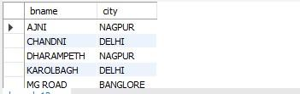

1. **Inserting values into Customer table**

| ANIL | CALCUTTA |
| --- | --- |
| SUNIL | DELHI |
| MEHUL | BARODA |
| MANDAR | PATNA |
| MADHURI | NAGPUR |
| PRAMOD | NAGPUR |
| SANDIP | SURAT |
| SHIVANI | BOMBAY |
| KRANTI | BOMBAY |
| NAREN | BOMBAY |

insert into branch values('VRCE','NAGPUR');

insert into customer values('NAREN','BOMBAY');

insert into customer values('KRANTI','BOMBAY');

insert into customer values('SHIVANI','BOMBAY');

insert into customer values('SANDIP','SURAT');

insert into customer values('PRAMOD','NAGPUR');

insert into customer values('MADHURI','NAGPUR');

insert into customer values('MANDAR','PATNA')

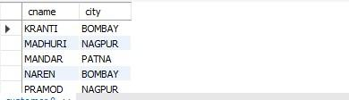

1. **Inserting values into Deposite table**

| Actno | Cname | Bname | Amount | Adate |
| --- | --- | --- | --- | --- |
| D100 | ANIL | VRCE | 1000.00 | 1-MAR-95 |
| D101 | SUNIL | ANJNI | 500.00 | 4-JAN-96 |
| D102 | MEHUL | KAROLBAGH | 3500.00 | 17-NOV-95 |
| D104 | MADHURI | CHANDNI | 1200.00 | 17-DEC-95 |
| D105 | PRAMOD | MG ROAD | 3000.00 | 27-MAR-96 |
| D106 | SANDIP | ANDHERI | 2000.00 | 31-MAR-96 |
| D107 | SHIVANI | VIRAR | 1000.00 | 5-SEP-95 |
| D108 | KRANTI | NEHRU  PLACE | 5000.00 | 2-JUL-95 |
| D109 | MINU | POWAI | 7000.00 | 10-AUG-95 |

1. **Inserting values into borrow table**

| L201 | ANIL | VRCE | 1000.00 |
| --- | --- | --- | --- |
| L206 | MEHUL | AJNI | 5000.00 |
| L311 | SUNIL | DHARAMPETH | 3000.00 |
| L321 | MADHURI | ANDHERI | 2000.00 |
| L371 | PRAMOD | VIRAR | 8000.00 |
| L481 | KRANTI | NEHRU PLACE | 3000.00 |

# EXPERIMENT NO. 2

To familiarize with selecting data from single table

# Questions

1. List all data from table deposite
2. List all data from borrow
3. List all data from customer
4. List all data from branch
5. Give account no and amount of deposite
6. Give customer name and account no of depositors
7. Give name of customers
8. Give name of branches
9. Give name of borrows
10. Give names of customer living in city Nagpur
11. Give names of depositors having amount greater than 4000
12. Give account date of Anil
13. Give name of all branches located in Bombay
14. Give name of borrower having loan number l205
15. Give names of depositors having account at VRCE
16. Give names of all branched located in city Delhi
17. Give name of the customers who opened account date ‘1-12-96’
18. Give account no and deposit amount of customers having account opened between dates ‘1-12-96’ and ‘1-5-96’
19. Give name of the city where branch KAROLBAGH is located
20. Give details of customer ANIL 